**Technical Documentation: EduConnect Ghana**

**1. Project Overview**

**Project Name:** EduConnect Ghana  
**Project Theme:** Digital Solutions for Local Challenges in Ghana  
**Domain:** Education  
**Objective:** Develop a web application that connects students with educational resources and volunteer tutors, addressing gaps in access to quality education in Ghana.

**2. System Architecture**

**2.1 Frontend**

* **Languages:** HTML5, CSS3, JavaScript (ES6+)
* **Design Approach:** Mobile-first, responsive layout
* **Key Components:**
  + **Hero Section:** Engaging introduction with call-to-action buttons
  + **Resource Section:** Filterable educational materials
  + **Tutor Section:** Location-based tutor search
  + **About Section:** Mission, team, and impact statistics

**2.2 Backend (Potential Future Implementation)**

* **API Integration:** For dynamic data loading (currently simulated with JavaScript arrays)
* **Database:** MongoDB/MySQL for storing resources, tutors, and user data
* **Authentication:** JWT for secure user logins (volunteers/students)

**2.3 Data Flow**

Diagram

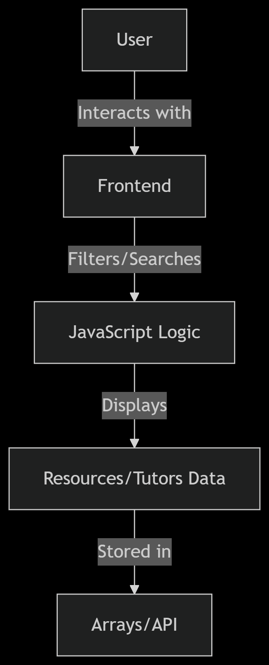

**3. Key Features**

**3.1 Resource Management**

* **Dynamic Filtering:**

javascript

function filterResources() {

const selectedSubject = subjectFilter.value;

const selectedLevel = levelFilter.value;

// Filter logic...

}

* **SVG Icons:** Subject-specific vector icons for visual categorization.

**3.2 Tutor Search**

* **Location-Based Search:**

javascript

function searchTutors() {

const locationQuery = locationSearch.value.trim().toLowerCase();

// Filter tutors by location...

}

**3.3 About Section**

* **Impact Metrics:** Displayed via animated counters.
* **Team Profiles:** Initial-based avatars (no external images).

**4. Technical Specifications**

**4.1 HTML Structure**

* **Semantic Tags:** <section>, <article>, <header>, <footer>
* **Accessibility:** ARIA labels, alt text for SVGs

**4.2 CSS Methodology**

* **Variables:**

css

:root {

--primary-color: #FF6B00;

--secondary-color: #0047AB;

}

* **Flexbox/Grid:** For responsive layouts.
* **Animations:** Floating icons, hover effects.

**4.3 JavaScript**

* **DOM Manipulation:** Dynamic content rendering.
* **Event Listeners:** For filters and search.
* **Service Worker:** Basic PWA functionality.

**5. Setup & Deployment**

**5.1 Local Development**

1. **Clone Repository:**

bash

git clone https://github.com/your-repo/educonnect-ghana.git

1. **Run:**
   * Open index.html in a browser.

**5.2 Production Deployment**

1. **Hosting:** Netlify/Vercel/Firebase Hosting.
2. **PWA Setup:**
   * manifest.json for installability.
   * Service worker for offline caching.

**6. Future Enhancements**

| **Feature** | **Priority** | **Description** |
| --- | --- | --- |
| User Authentication | High | Sign-up for tutors/students |
| Chat System | Medium | In-app messaging |
| PDF Viewer | Low | Integrated document reading |

**7. Testing**

* **Manual Tests:**
  + Filter resources by subject/level.
  + Search tutors by location.
* **Cross-Browser:** Chrome, Firefox, Safari.
* **Mobile:** Responsive on all screen sizes.

**8. Conclusion**

EduConnect Ghana is a technically sound solution addressing educational access challenges in Ghana. The frontend is complete with:  
✅ Resource filtering  
✅ Tutor search  
✅ Impactful About section  
✅ Responsive design

**Next Steps:** Implement backend API for real-time data.

**Appendix:**

* Full JavaScript Code
* CSS Stylesheet
* Sample Data Structures